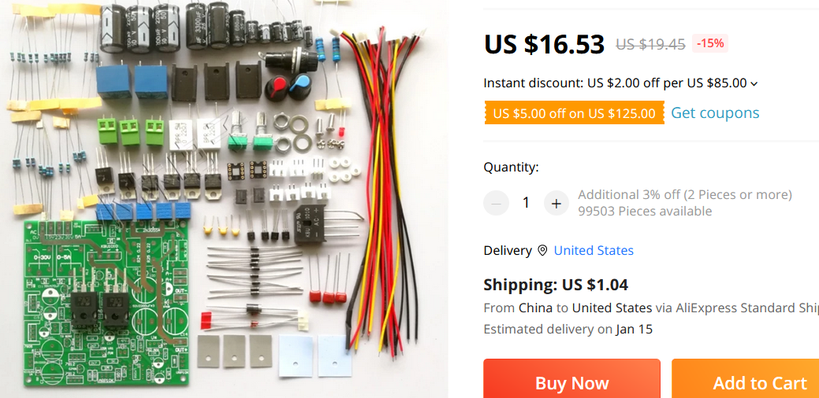Install fuse for AC incoming line.  
If the potentiometer is disconnected during use, there will be 30V voltage and 5A current output!   
The circuit component parameters are 30V5A design, please do not change the output voltage and current at will!  
The kit does not include:  
  
 150W-180W transformer (current 5A) with 3 voltage output values 15V 23V 31V (5A) (schematic says 15,25,35),  
  
A dual 12V to dual 15V current 1A transformer,  
  
Voltage and current meter,

Heat sinks for the TIP3055s,  
  
12V 0.2A cooling fan,

Case and red and black terminals.  
  
   
  
Simple circuit description:  
  
L1 is the auxiliary control power supply, a center-tapped dual 12V to dual 15 voltage and current 1A transformer. It needs to use the same on-off switch as the L2 main transformer to control on-off.  
L2 is the main voltage output. If the output is to be 30V, the voltage is 0V-15V-23V-31V.   
(Note that the voltage after rectification should be within 50V! Preferably within 40V!!!)  
The main voltage transformer can also choose the commonly used center tapped double 13V double 14 double 15 with a current of 5A.  
The 3 wire ends of such a 5A dual output are connected to the first 3 terminal blocks in turn.The fourth terminal block is empty. At this time, the relay RL2 is not installed,  
short-circuit the 2 normally closed pins of RL2. There is a picture below.  
 Auxiliary control supporting electrolysis 25V2200\*2 or 3300\*2.          7.5K for 2K 3W in the main voltage bleeder resistor circuit diagram \*2  
  
    50V2200UF\*3 for main voltage filtering (total capacity should not be greater than 6600uF)  
  
   The 2 external potentiometers for adjusting voltage and current can be replaced with stable and reliable multi-turn adjustable by themselves!  
  
   
  
 (Change explanation: When the load is open or light load, the voltage will have a relatively large overshoot when the original circuit is shut down.  
  
  1. To reduce the bleeder resistance of the main filter capacitor, reduce 7.5K to 2k.  
  
  2. C1 and c2 should be increased to 2200uf or 3300uf. The purpose is to control the power retention time of the circuit capacitor to be longer than the power retention time of the main filter capacitor, so as to prevent the control circuit (auxiliary circuit) from losing power and causing the output voltage of the main circuit to lose control)  
  
  3. The voltage potentiometer will output the highest voltage after poor contact or disconnection. Please try to replace a higher quality potentiometer.  
  
  
  
The principle of constant voltage and constant current:  
According to U=IR, R=U/I:  
If R>(U/I), the power supply works normally.  
If R<(U/I), I is constant, the constant current part of the power supply is protected, and the output voltage drops until the condition R=(U/I) is met.  
  
characteristic:  
The so-called constant voltage means that the voltage can be constant to a value, and the constant voltage is adjustable, that is, the constant voltage value is adjustable.  
The so-called constant current, that is, the current can be constant to a value, adjustable constant current, that is, the constant current value is adjustable.  
  
  
use:  
Before using the adjustable constant voltage and constant current power supply, you need to set the constant current protection value first, then set the output voltage, and then start working.  
First adjust the output voltage of the power supply to about 5V, short-circuit output, adjust the current output knob to set the protection current to the value you need, cancel the short-circuit, adjust the voltage to the required value, connect the experimental equipment and start working.  
  
For example: the operating voltage of a circuit is 12V and the required current is about 0.3A. The operation is as follows.  
Adjust the power supply output voltage to about 5V, short-circuit output, adjust the current output knob to set the protection current 0.5A (slightly larger than the working current), cancel the short-circuit, adjust the voltage to 12V, connect the circuit to start the experiment.  
If the circuit board is placed on the metal part of the circuit during the test, the current will increase sharply. When the current rises to 0.5A, the constant current protection part of the power supply will work even if the output voltage drops to protect the test equipment.  
  
Common sense understanding:  
After the AC voltage is filtered by the full-wave rectifier capacitor, the DC voltage is approximately 1.414 times the AC voltage.  
For example, a 10V AC voltage is approximately equal to 14V after being filtered by a full-wave rectifier capacitor. Selection of relay switching point:  
The AC input voltage minus 5V equals the switching voltage.  
For example, transformer tap 0-15V-25V-35  
Then the switching voltage of the first stage is 15V-5V=10V, that is, it switches to a 25V tap at 10V.  
The switching voltage of the second stage is 25V-5V=20V, that is, it switches to a 35V tap at 20V.  
Whether the relay is switched or not can be judged by measuring the voltage across R17. The voltage of R17 (DC) divided by 1.414 is approximately equal to the current tap voltage (AC).  
  
Preparation before commissioning:  
After the installation is checked and correct (capacitors and diodes at the output must be installed; TIP3055 must be installed on a large radiator), if you do not connect the ammeter, please short-circuit the ammeter contact "A" and then power on.  
Please refer to the schematic:  
Measure the voltage of C1 and C2, it should be 12-25V as normal.  
Measure C11 voltage, it is normal if it is less than 30V.  
Measure C15 voltage, 12V is normal.  
If the above voltage is abnormal, please check whether the transformer is supplying power, whether the taps are connected wrongly, and whether the components are installed incorrectly. Repeat the above steps until the voltage is normal.  
  
Debugging process:  
Adjust VR3 and VR4 to make the voltage of U2 chip 2 and 6 pins above 10V  
  
(Take the 4 feet of U2 as a reference point).  
The voltage across R17 should be the rectified and filtered voltage of the first-stage tap of the transformer.  
Turn the A-RP current knob to the middle, and the constant current indicator LED1 should be off at this time.  
Adjust V-RP, the voltage can be adjusted around 0-18V (R17 voltage) and it is normal.  
The output voltage is adjusted to the first-stage relay switching point voltage  
  
(If you don't understand, go to the "Relay switching point selection"). Adjust VR3 to make RL1 pull in. RL2 should not pull in at this time. At this time, the voltage of R17 should be the rectified voltage of the second stage tap.  
  
Adjust the output voltage to the second-stage relay switching point voltage (if you don't understand, go to the "Relay switching point selection"), adjust VR4 to make RL2 pull in. At this time, the R17 voltage should be the third-stage tap rectified voltage.  
  
Adjust the output voltage to see if the two relays will be closed near the switching point. Can not be sucked and repeat the above steps, can suck and continue.  
Adjust V-RP to see the voltage output range. Adjust V-RP to maximize the output voltage. If the maximum voltage is not 30V, adjust VR2 to make the maximum voltage 30V.  
  
Adjust constant current:  
First, make sure that the adjusting tube has a large enough radiator and good heat dissipation.  
Adjust the voltage to 5V, use an ammeter to test short-circuit output, and see if the constant current indicator LED1 is on?  
If it does not light up, there is a problem with the constant current circuit. Check whether the components are installed incorrectly, and whether the LED1 is installed.  
If it is on, it is short-circuited. Adjust A-RP to the maximum short-circuit current. If the maximum current is not 5A, adjust VR1 to make the current 5A.  
  
Regarding the temperature-controlled fan VR5, when the radiator is hot to a certain level, you think the cooling fan needs to work, just adjust VR5 to make the fan work.  
  
At this point, your power supply can be put into use.

